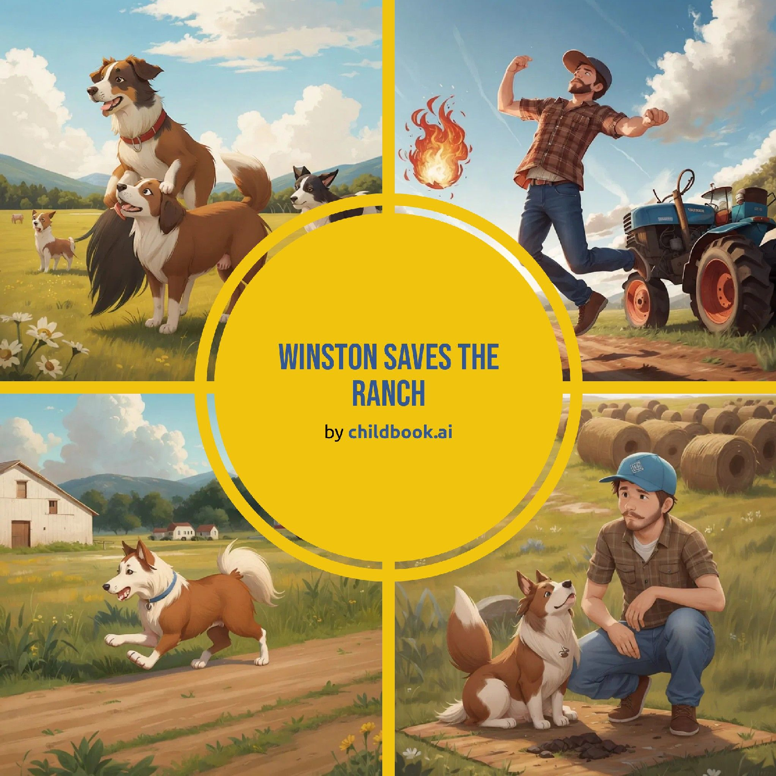

It was a sunny morning on the ranch. Winston, the clever Border Collie, was excited to help Farmer Ben. Farmer Ben was cutting and baling hay for the animals to eat during the winter. The highland cows, horses, and chickens watched as the tractor moved across the field. Winston loved his job and felt proud to be part of the team.

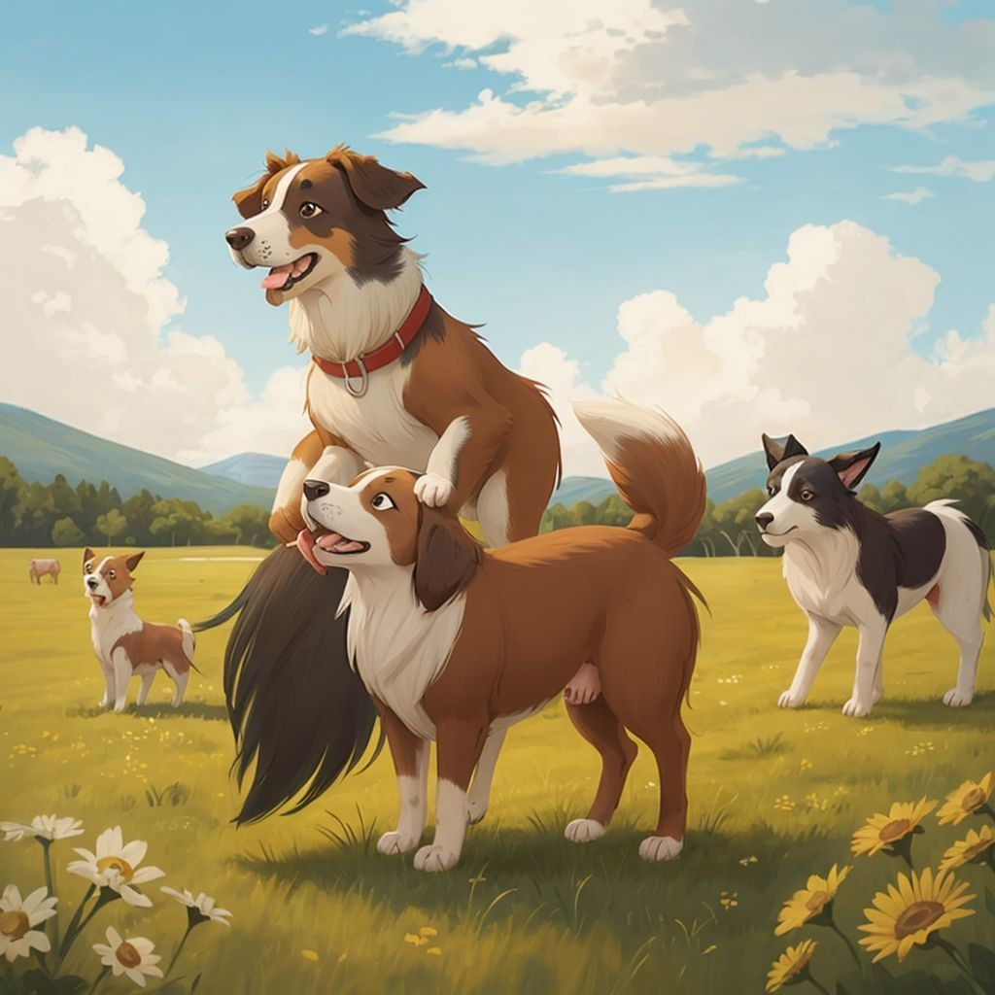

Suddenly, a loud noise came from the baler. Farmer Ben jumped off the tractor to see what was wrong. To his horror, he saw flames coming from the machine. The fire began to spread quickly across the dry hay. Winston felt scared but knew he had to do something.



Farmer Ben shouted, 'Winston, go get help!' Winston darted off towards the volunteer fire department. He ran as fast as his legs could carry him, dodging through the fields and past the barns. When he arrived, he barked loudly to get the firefighters' attention. They quickly understood and followed Winston back to the ranch.

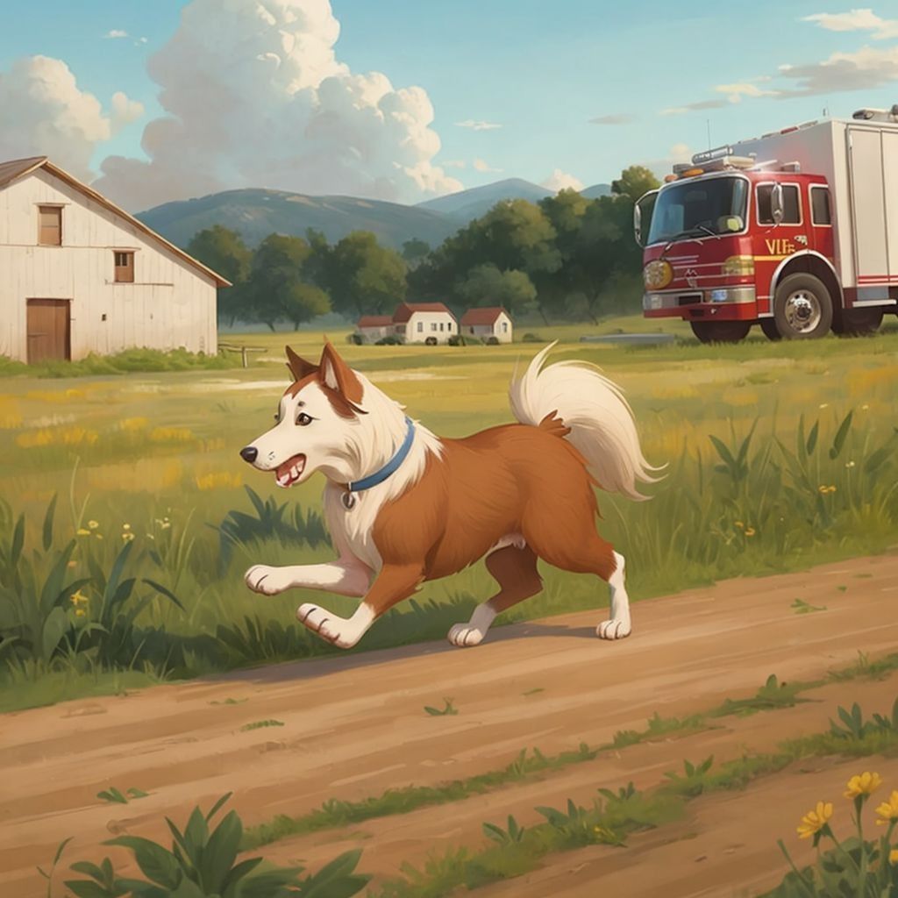

The firefighters arrived just in time to put out the fire. Farmer Ben was so grateful to Winston for his bravery. Though the hay field was burned, everyone was safe. Winston received extra pats and treats for his heroic actions. He learned that even when you're scared, being brave can make a big difference.

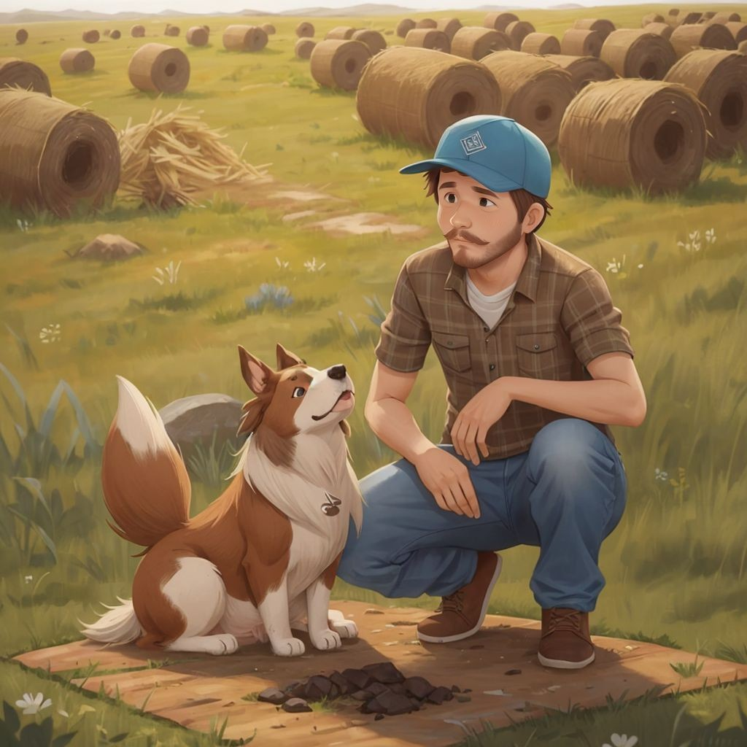

SPARK YOUR CHILD's IMAGINATION

AND CREATE PERsONALIZED CHILDREN's BOOKs WITH CHILDBOOK.AI!

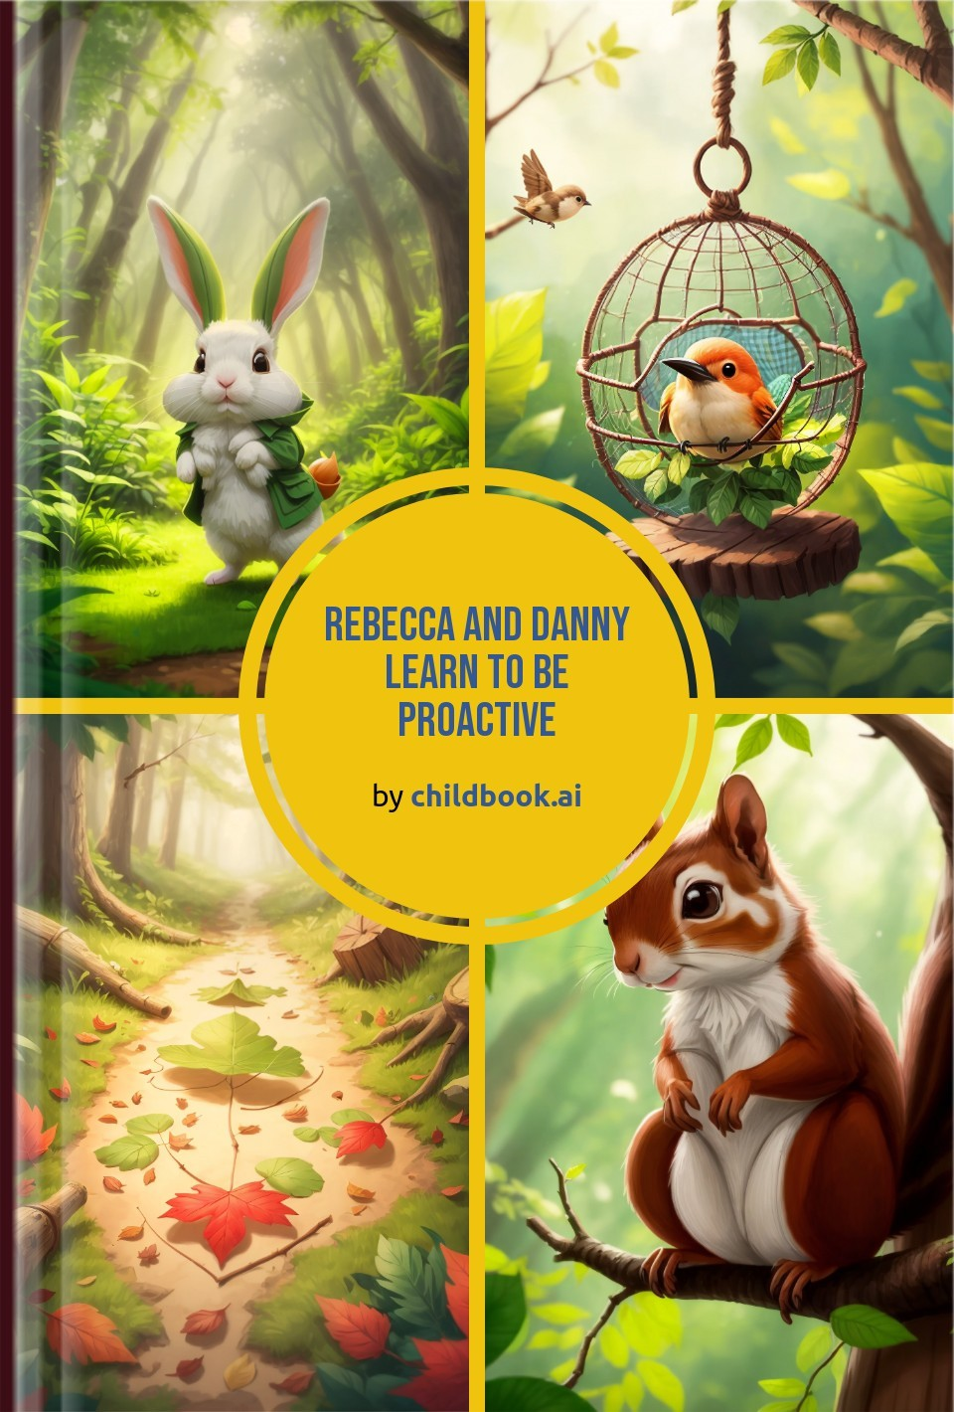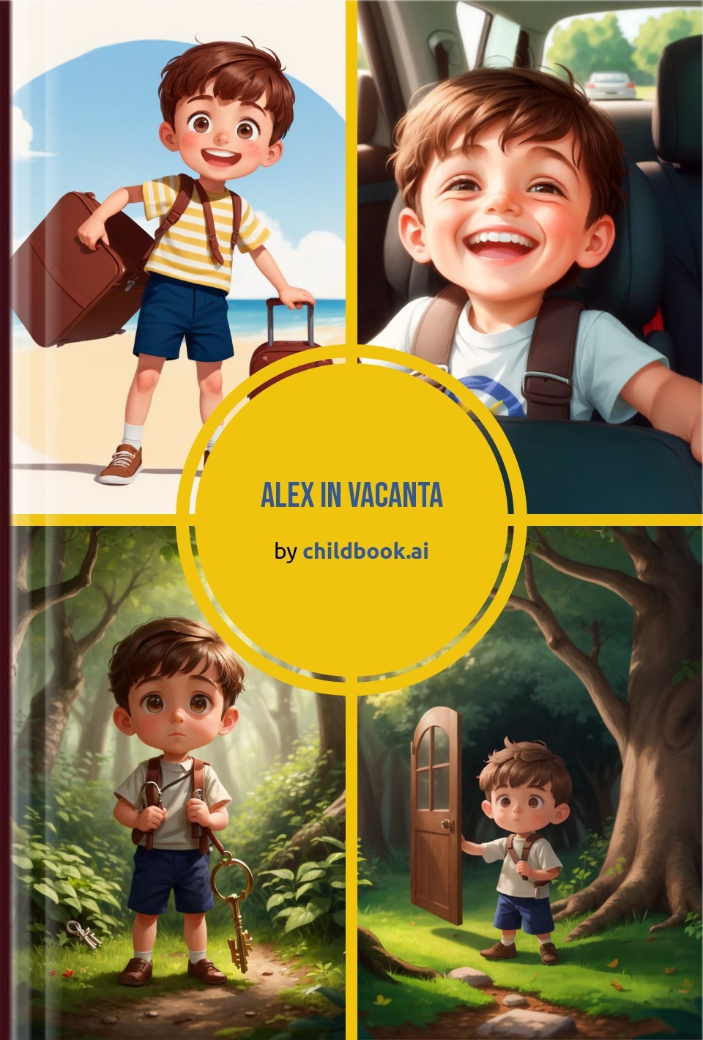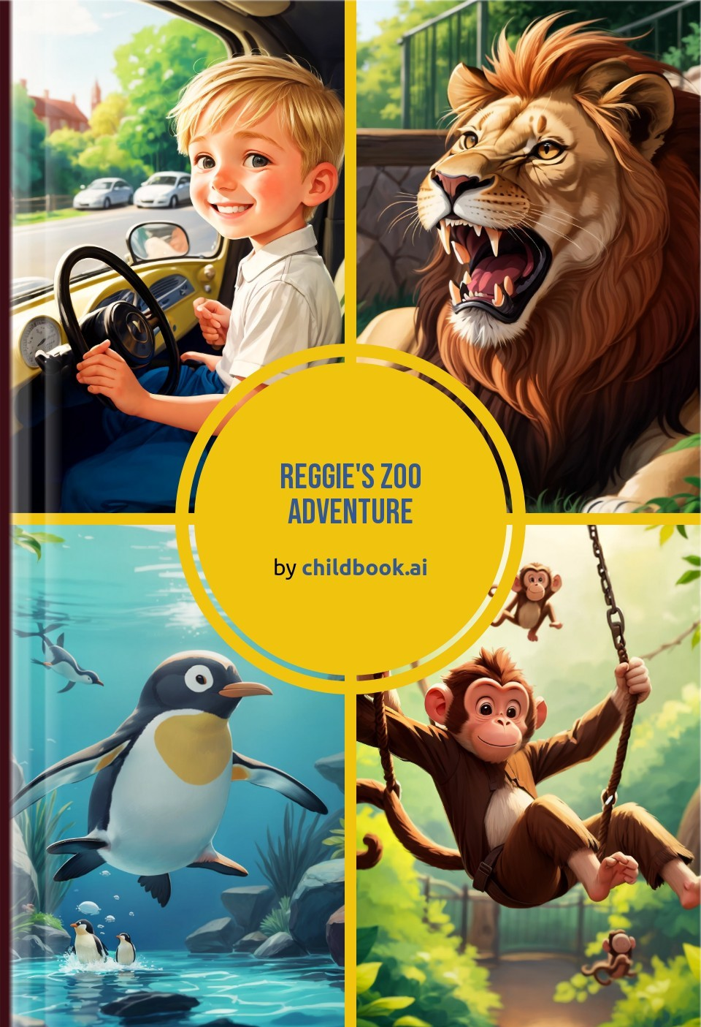

Create a unique children's story with our easy-to-use ai storybook maker. Our personalized children's books are fully customized with original characters, illustrations, and an imaginative plot.